**REMOTE BLUETOOTH CONTROLLED LEDS WITH VARIABLE INTENSITY**

**Introduction**

The main objective of the project is to develop a remote controlled light using an Arduino with HC-05 Bluetooth module remotely being controlled by a bluetooth enabled Android device. As technology is advancing, houses are getting smarter.

Modern houses are gradually shifting from conventional switches to centralized control systems, involving remote controlled switches. Presently, conventional wall switches located at different parts of the house makes it difficult for the user to go near them and operate. It becomes even more difficult for the old aged and handicapped people to do so. Remote controlled home automation provides us the most modern solution with smart phones.

In order to achieve this, a Bluetooth module is interfaced with Arduino board at the receiver end and while on the transmitting end, a GUI application on the cell phones sends commands to the receiver where load is connected.

Why did we decide to make this project?

The main objective of this project is to help old aged and handicapped people, and also to make a smarter living.

**Materials and Methods**

**Components used:**

* Hardware:

|  |  |  |  |
| --- | --- | --- | --- |
| S. No. | Component | Picture | Description |
|  | HC-05 Bluetooth Module |  | It is an easy to use bluetooth SPP (Serial Port Protocol) module, designed for transparent wireless serial connection setup. It can be used in a Master or Slave configuration, making it a great solution for wireless communication. |
| 2. | Breadboard |  | A breadboard is a solderless device for temporary prototype with electronics and test circuit designs. Most electronic components in electronic circuits can be interconnected by inserting their leads or terminals into holes and then making connections through wires wherever appropriate. |
| 3. | Arduino Board |  | It is a microcontroller board based on the Atmega328P.It has 14 digital input/output pins, 6 analog inputs, a 16 Mhz quartz crystal, a USB connection, a power jack and a reset button. |
| 4. | Resistor |  |  |
| 5. | LED |  |  |

Mechanical Materials:

* Wood
* Acrylic Sheet
* Fevicol
* Software:

Arduino IDE:

It contains a text editor for writing code, a message area, a text console, a toolbar with buttons for common functions and a series of menus. It connects to the Arduino to upload programs and communicate with them.

Fritzing:

Fritzing is an open source hardware initiative that makes electronics accessible as a creative material for anyone. It is a software tool and community website for processing and Arduino, fostering a creative ecosystem which allows users to document their prototypes, share them with others, and manufacture professional PCB’s.

**Method:**

Step 1:

To wire up Arduino and HC-05 as the given circuit diagram to ensure all the devices work.

Powering Arduino using USB:

Tx >> Rx

Rx >> Tx

Vcc >> +5V

Gnd >> Gnd

Pin 9 >> 3 LED’s

Pin 10 >> 3 LED’s

Pin 11 >> 3 LED’s

Gnd >> LED Array

Step 2: Remove Tx and Rx pins and develop sketch for Arduino.

Step 3: Using the USB cable, upload the sketch and reconnect the Rx and Tx pins.

Step 4:

Download ROBOREMO app from playstore on Android device and

1. Open Menu and enter ‘edit ui’
2. Click on screen and add 5 buttons and place/size them to your wish.
3. Click on each button and name 4 of them according to your choice and name the 5th one as OFF by using the set text option.
4. Now, for the OFF button, select ‘set press action’ and set the value to 0.
5. For the rest of the 4 buttons, using the ‘set press action’, set the values to 25, 75, 135 and 255.
6. Now click ‘menu’ and select ‘dont edit ui’.

Step 5:

1. Open your bluetooth settings and select HC-05 to pair
2. Password by default is either 1234 or 0000
3. After pairing, return to ROBOREMO app and open menu.
4. Select ‘connect’ button.
5. Now select bluetooth.
6. Now select HC-05.

Step 6:

1. Position your LED’s in the way you want and solder the 3 LED’s together.
2. Now solder the Final LED’s grounds together.
3. Connect the 3 LED’s arrays to respective pins.
4. Connect the ground of the LED array to the ground of the Arduino board.

**Schematics**

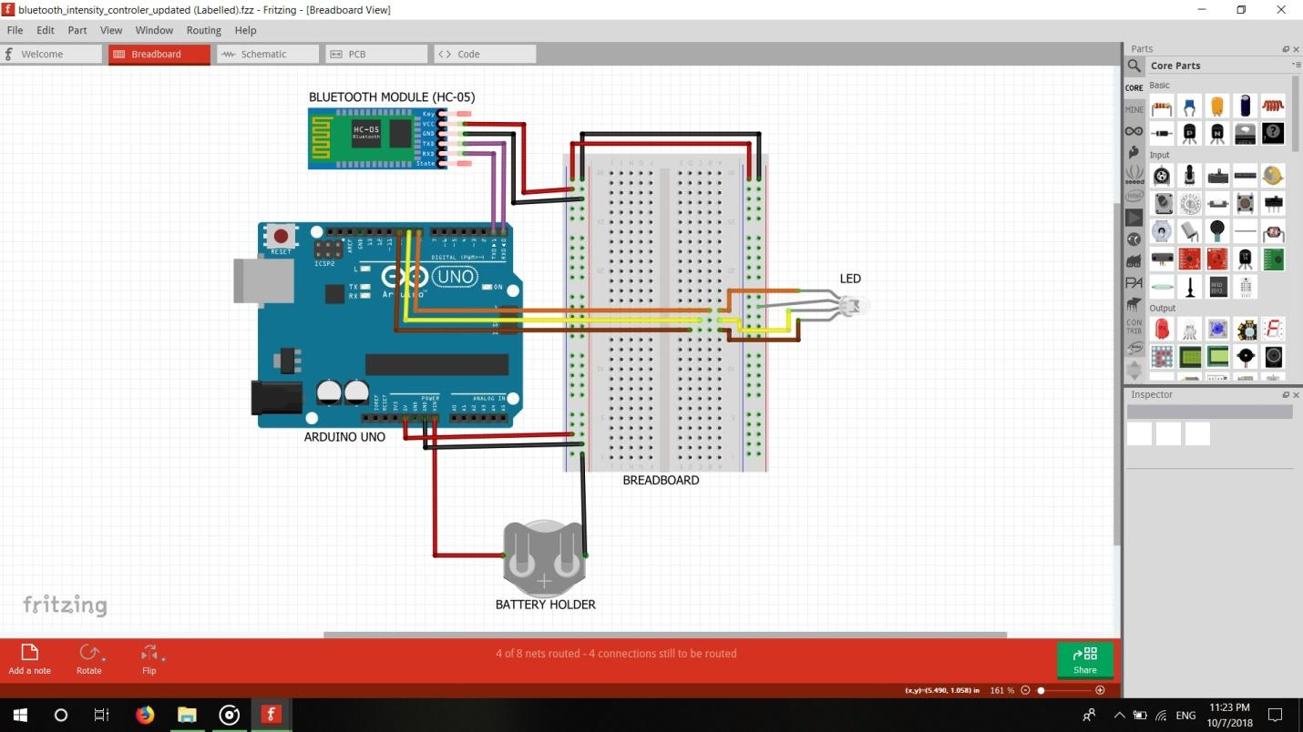

**Cad Model**

**Steps:**

1. Take the base with dimension of (126.8*50)mm.
2. Then make the side walls with height 30 mm.
3. Then insert electronic components in box or house.
4. Then cover the top with acrylic

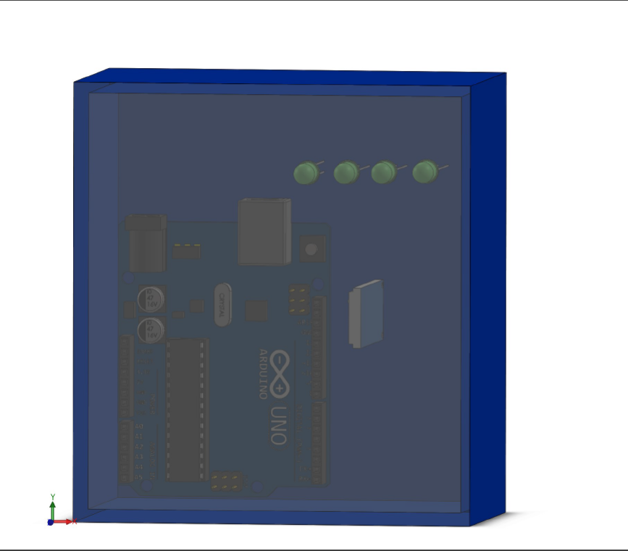

**Future Prospects**

1. The prime objective of the Home Automation system is to assist handicapped and old aged people.
2. As this project is based on Arduino and Android platforms, the overall implementation cost is very cheap and it is affordable to common people.
3. Most people can get benefit as it is based on Android platform.
4. It is helpful in saving the electricity.